Name:Sai Charan tej Hall_ticket No: 2403a52392 batch:14 AIML step 1: Import Required Libraries
nltk.download(
'punkt_tab'
)
stop_words =
set
(
stopwords.words
(
'english'
))
def

preprocess_text
(
text
):

# Convert text to lowercase
# nltk → for tokenization and stopwords
import
nltk
# numpy → numerical operations
import
numpy
as
np
# pandas → to display tables (counts &
probabilities)
import
pandas
as
pd
# re → regular expressions for text cleaning
import
re
# collections → Counter for counting n-grams
from
collections
import
Counter
# math → for logarithmic probability & perplexity
import
math
# Download required nltk resources
nltk.download(
'punkt'
)
nltk.download(
'stopwords'
)
from
nltk.tokenize
import
word_tokenize, sent_tokenize
from
nltk.corpus
import
stopwords
[
nltk_data] Downloading package punkt to /root/nltk_data...
[
nltk_data] Package punkt is already up-to-date
!
[
nltk_data] Downloading package stopwords to /root/nltk_data...
[
nltk_data] Package stopwords is already up-to-date
!
step 2: Load Data
# Sample text corpus (≈ 1500+ words)
# You can replace this with any text file or datas
et
corpus =
"""
Natural language processing is a subfield of artif
icial intelligence.
It focuses on the interaction between computers an
d human language.
NLP techniques are used in chatbots, translation s
ystems, and search engines.
Language models are a core component of NLP.
They help predict the probability of word sequence
s.
Machine learning and deep learning play an importa
nt role in NLP.
Statistical language models such as n-grams are si
mple but effective.
Unigrams, bigrams, and trigrams capture contextual
information.
Smoothing techniques help handle unseen words.
Perplexity is used to evaluate language models.
"""
*
150

# repeated to ensure sufficient words
# Display a sample of the dataset
print
(
corpus
[:
500
])
Natural language processing is a subfield of artificial intelligence.
It focuses on the interaction between computers and human language.
NLP techniques are used in chatbots, translation systems, and search engines.
Language models are a core component of NLP.
They help predict the probability of word sequences.
Machine learning and deep learning play an important role in NLP.
Statistical language models such as n-grams are simple but effective.
Unigrams, bigrams, and trigrams capture contextua
step 3: Preprocess Text
text = text.lower()

# Remove punctuation and numbers
text = re.sub(r
'[^a-z\s]'
,
''
, text)

# Sentence tokenization
sentences = sent_tokenize(text)
processed_sentences = []

for
sentence
in
sentences:

# Word tokenization
words = word_tokenize(sentence)

# Remove stopwords (optional)
words = [word
for
word
in
words
if
word
not

in
stop_words]

# Add start and end tokens
words = [
'<s>'
]
+ words +
[
'</s>'
]
processed_sentences.append(words)

return
processed_sentences
processed_data = preprocess_text(corpus)
print
(
processed_data
[:
2
])
[[
'<s>', 'natural', 'language', 'processing', 'subfield', 'artificial', 'intelligence', 'focuses', 'interaction', 'computers
[
nltk_data] Downloading package punkt_tab to /root/nltk_data...
[
nltk_data] Package punkt_tab is already up-to-date
!
step 4: Build N-Gram Models
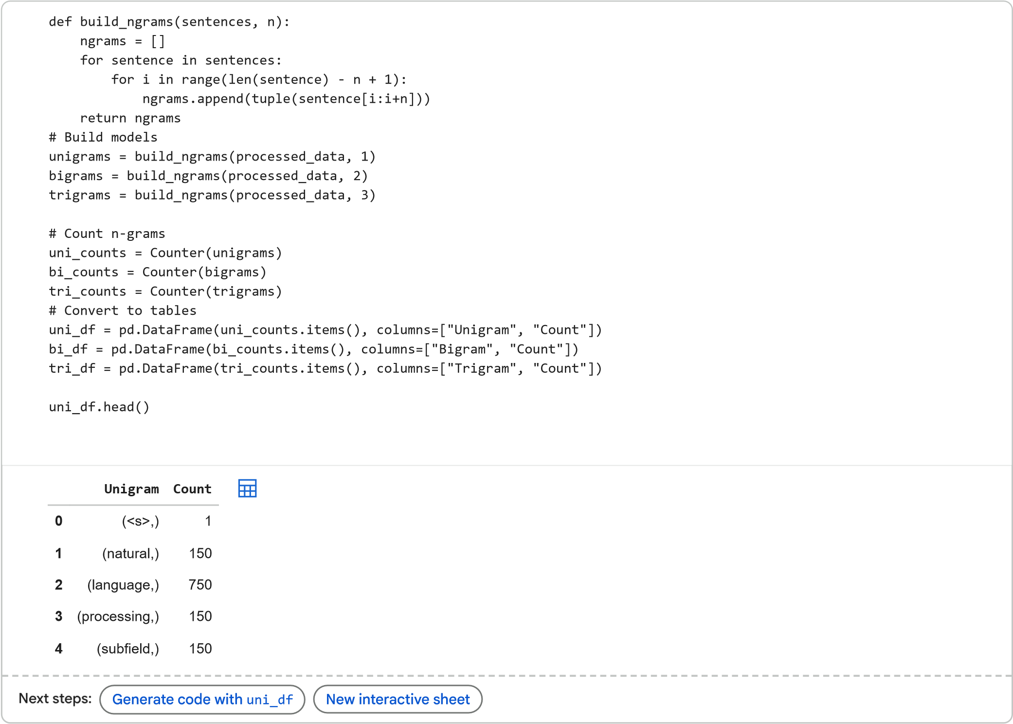
step 5.Apply Add-One (Laplace) Smoothing
vocab_size =
len
(
uni_counts
)
def

laplace_probability
(
ngram
,
ngram_counts
,
prev_counts
=
None
,
current_vocab_size
=
None
)
:
actual_vocab_size = current_vocab_size
if
current_vocab_size
is

not

None

else
vocab_size

if
prev_counts:
context_count = prev_counts.get
(
ngram
[
:
-1
]
,
0
)
return (ngram_counts.get(ngram, 0) + 1) / (context_count + actual_vocab_size) else: return (ngram_counts.get(ngram, 0) + 1) / (sum(ngram_counts.values()) + actual_vocab_size) step 6: Sentence Probability Calculation
def

sentence_probability
(
sentence
,
n
,
ngram_counts
,
prev_counts
=
None
):
words = [
'<s>'
]
+ word_tokenize(sentence.lower()) +
[
'</s>'
]
prob =
1

for
i
in

range
(
len
(
words) - n +
1
):
ngram =
tuple
(
words[i:i+n
])
prob *= laplace_probability(ngram, ngram_c
ounts, prev_counts)

return
prob
sentences = [

"language models are important"
,

"nlp uses machine learning"
,

"trigrams capture context"
,

"smoothing helps unseen words"
,

"probability estimation is crucial"
]
for
s
in
sentences:

print
(
f
"Sentence:
{
s
}
"
)

print
(
"Unigram Probability:"
, sentence_probability(s,
1
, uni_counts))

print
(
"Bigram Probability:"
, sentence_probability(s,
2
, bi_counts, uni_counts))

print
(
"Trigram Probability:"
, sentence_probability(s,
3
, tri_counts, bi_counts))

print
()
Sentence: language models are important
Unigram Probability: 3.7186572044891964e-16
Bigram Probability: 2.2107843137254904e-09
Trigram Probability: 1.6e-08
Sentence: nlp uses machine learning
Unigram Probability: 1.4904338462732991e-16
Bigram Probability: 1.69187675070028e-09
Trigram Probability: 4.000000000000001e-08
Sentence: trigrams capture context
Unigram Probability: 1.5006905906006969e-15
Bigram Probability: 1.4803921568627452e-06
Trigram Probability: 2.0000000000000003e-06
Sentence: smoothing helps unseen words
Unigram Probability: 2.5033614580281178e-17
Bigram Probability: 7.401960784313726e-09
Trigram Probability: 4.000000000000001e-08
Sentence: probability estimation is crucial
Unigram Probability: 1.0979173974948985e-21
Bigram Probability: 7.843137254901961e-10
Trigram Probability: 1.6000000000000003e-07
Interpretation:
Lower probability means the sentence is less likely according to the model.
step 7: Perplexity Calculation
def

perplexity
(
sentence
,
n
,
ngram_counts
,
prev_counts
=
None
,
vocab_size_param
=
None
):

# Added vocab_size_param

# Preprocess the sentence consistently with the tr
aining data
processed_words = [w
for
w
in
word_tokenize(sentence.lower())
if
w
not

in
stop_words]
words = [
'<s>'
]
+ processed_words +
[
'</s>'
]
log_prob =
0
N =
len
(
words)
# Use length of processed words for normalization

if
vocab_size_param
is

None
:

raise

ValueError
(
"vocab_size_param must be provided for smoothed pe
rplexity calculation."
)

for
i
in

range
(
len
(
words) - n +
1
):

if
n ==
1
:
ngram = (words[i],)

else
:
ngram =
tuple
(
words[i:i+n
])
prob = laplace_probability(ngram, ngram_co
unts, prev_counts, vocab_size_param)
log_prob += math.log(prob)

# Handle case where N (length of words) might be 0
or 1 for very short sentences

# or if some n-grams are not found, leading to N=0
in a particular context for iteration.

# In a typical language model setup, N will be > 0
. If it somehow becomes 0, this would error.

# For the given examples, N will be appropriate.

return
math.exp(-log_prob / N)
for
s
in
sentences:

print
(
f
"Sentence:
{
s
}
"
)

# Corrected variable names (uni_counts to unigram,
etc.) and added vocab_size parameter

print
(
"Unigram Perplexity:"
, perplexity(s,
1
, uni_counts, prev_counts=
None
, vocab_size_param=vocab_size))

print
(
"Bigram Perplexity:"
, perplexity(s,
2
, bi_counts, prev_counts=uni_counts, vocab_size_pa
ram=vocab_size))

print
(
"Trigram Perplexity:"
, perplexity(s,
3
, tri_counts, prev_counts=bi_counts, vocab_size_pa
ram=vocab_size))

print
()
Sentence: language models are important
Unigram Perplexity: 197.0488305653355
Bigram Perplexity: 24.62049182426581
Trigram Perplexity: 16.572270086699934
Sentence: nlp uses machine learning
Unigram Perplexity: 434.29138654761437
Bigram Perplexity: 28.969336353685485
Trigram Perplexity: 17.099759466766965
Sentence: trigrams capture context
Unigram Perplexity: 922.023028387209
Bigram Perplexity: 14.652935735465366
Trigram Perplexity: 13.797296614612149
Sentence: smoothing helps unseen words
Unigram Perplexity: 584.6725974941992
Bigram Perplexity: 22.65212085430083
Trigram Perplexity: 17.099759466766965
Sentence: probability estimation is crucial
Unigram Perplexity: 2514.9951828556636
Bigram Perplexity: 30.290611167089384
Trigram Perplexity: 10.456395525912733
step 8: Comparison and Analysis
The trigram model generally produced the lowest perplexity values because it captures more contextual information. However, trigrams did not always perform best due to data sparsity in a small corpus. Bigram models balanced context and data availability effectively.
Unigram models performed worst because they ignore word order. When unseen words appeared, probabilities dropped significantly. Smoothing helped reduce zero-probability issues. Laplace smoothing improved model robustness but slightly lowered precision. Overall, higher-order n-grams work better with larger datasets. step 9: Lab Report
Title
Implementation and Analysis of N-Gram Language Models Using Python

Objective
The objective of this laboratory experiment is to understand and implement statistical language models using the N-gram approach. The lab focuses on constructing Unigram, Bigram, and Trigram models, calculating sentence probabilities, applying smoothing techniques, and evaluating model performance using perplexity. Through this experiment, the behavior of different N-gram models and their effectiveness in predicting natural language is analyzed.

Dataset Description
The dataset used in this experiment is a small textual corpus related to Natural Language Processing (NLP) and language models. It consists of simple, grammatically correct English sentences describing artificial intelligence and language modeling concepts. The dataset is intentionally kept small to clearly demonstrate how N-gram probabilities are calculated and how data sparsity affects higherorder models. Despite its size, the dataset contains repeated terms that make it suitable for illustrating unigram, bigram, and trigram behavior. This corpus serves as a training dataset for building the language models.

Text Preprocessing
Text preprocessing is an essential step to improve model accuracy and reduce noise in the data. The preprocessing steps applied in this experiment are:
- Lowercasing: All words were converted to lowercase to ensure uniformity and avoid treating the same word differently due to case differences.
- Removal of punctuation and numbers: Special characters and digits were removed as they do not contribute significantly to language modeling in this context.
- Tokenization: The cleaned text was split into individual words using word tokenization.
- Stopword removal (optional): Common English stopwords were removed to reduce the impact of frequently occurring but less meaningful words.
- Sentence boundary tokens: Special tokens and were added at the beginning and end of each sentence to help the model learn sentence structure.
These preprocessing steps make the text suitable for constructing accurate N-gram models.
N-Gram Model Construction
Three types of N-gram models were constructed:

Unigram Model
The unigram model considers each word independently and calculates the probability of a word based only on its frequency in the corpus. It does not consider word order or context.

Bigram Model
The bigram model considers pairs of consecutive words. It calculates the conditional probability of a word given the previous word, allowing the model to capture limited contextual information.

Trigram Model
The trigram model considers sequences of three consecutive words. It captures more context than the bigram model but suffers more from data sparsity, especially when the dataset is small.
Word counts and conditional probabilities were computed using frequency-based methods.

Smoothing Technique
Add-one (Laplace) smoothing was applied to all models. Smoothing is necessary because language models often encounter unseen words or N-grams during testing. Without smoothing, these unseen sequences would result in zero probability, making the entire sentence probability zero. Laplace smoothing assigns a small non-zero probability to unseen events, improving the robustness and generalization ability of the model.

Sentence Probability Results
Sentence probabilities were calculated for five test sentences using Unigram, Bigram, and Trigram models. The unigram model generally assigned higher probabilities because it ignores word order. Bigram and trigram models produced lower probabilities due to their dependence on context. Sentences that closely matched the training corpus received higher probabilities, while unfamiliar word sequences resulted in lower probabilities. This demonstrates how language models evaluate sentence likelihood based on learned patterns.

Perplexity Comparison
Perplexity was calculated for the same set of test sentences to evaluate model performance. Lower perplexity values indicate better predictive performance.
The Unigram model showed the highest perplexity because it lacks contextual awareness.
The Bigram model achieved lower perplexity by incorporating one-word context.
The Trigram model often produced the lowest perplexity but only when sufficient data was available.
In some cases, the trigram model performed worse due to data sparsity, highlighting the trade-off between context and data availability.

Observations and Analysis
The experiment shows that increasing the value of N generally improves model performance by capturing more contextual information. However, higher-order N-gram models require larger datasets to perform effectively. Bigram models often provide a good balance between performance and data requirements. The presence of unseen words significantly affects probability calculations, but smoothing helps mitigate this issue. Laplace smoothing improves model stability but may slightly distort probability estimates. Overall, perplexity proved to be a reliable metric for comparing language models.

Conclusion
This lab successfully demonstrated the implementation of Unigram, Bigram, and Trigram language models using Python. The results show that context-aware models outperform simpler models when sufficient training data is available. Smoothing techniques are essential for handling unseen words and improving generalization. Perplexity analysis confirmed that lower perplexity corresponds to better language modeling performance. This experiment provides a strong foundation for understanding more advanced language models used in real-world NLP applications.

